**Final Year Project research**

*Books:*

Game Usability: advancing the player experience by Katherine Isbister and Noah Schaffer

*Reference:*

*Notes:*

Video Kids: Making sense of Nintendo by Eugeune F.Provenzo, JR.

*Reference:*

*Notes:*

* Nintendo is profoundly aware that its main audience is the youth market
* Most games tend to feed into masculine fantasies of control and destruction. (pg. 50)
* Video games do not contribute to deviant behaviour but may in fact help adolescents and youths in their developmental process. This conclusion is strangely confirmed by Kestenbaum and Weinstein’s survey of nearly 500 junior high school students in an urban and middle-class neighbourhood. Experiments comparing the use of biofeedback mechanisms and video games with incarcerated youths conducted by Kappes and Thompson in 1985 also confirms Kestenbaum and Weinstein’s conclusions. (pg. 57)

Playing the game: insider views on video game development by NESTA

*Reference:*

*Notes:*

* Games are as important socially, culturally, and economically as music and film. They are certainly the preferred entertainment of choice of today’s youth. Moving out of the bedroom, people are enjoying playing games socially together in the living room. Games are now part of mainstream culture, a new art form that helps define what we are as human beings. (Pg. 115)
* Many games can be used as a learning tool as players face puzzles and solve problems, with choice and consequence, intuitive learning, micro-management, simulation, communication, social skills, character development, narrative structure, and even manual dexterity. (Pg. 115)

Play Anything: The pleasure of limits, the uses of boredom and the secret of games

*IMAT1909 – Game Architecture and Design – Week 11 Ethics 1*

Disability in Games: An issue often cited by disabled gamers, is that the characterisation of disabilities in games often focuses on:

* Negative role models – the archetypal “bad guy” with a limp
* Replacement or cure – a limb is blown off and replaced by a mechanical version.

A complex area as why should these not be characteristics of disabled people

*Week 15 – Game Ethics 2*

Representation of Disability:

Disability In Games: There is little research currently into the way in which disabilities are represented within the gaming media. More focus has been placed on accessibility. Two subjects are linked but separated as input (accessing the content) and output (how the content is displayed)

In Perception – Cassie is a blind character that navigates using the ambient noises of the house.

Jeff Rouner[1] comments that despite there being an increase in good characters (Joker in mass effect, for example), they are not protagonists. He continues to comment that many games have typical video game problems with over-compensation his missing body parts with a super powered one. A problem seen in Mortal Kombat’s Jax.

[2] Comment that “For the most part, if a game protagonist is physically disabled in some manner, it’s usually immediately fixed through the use of cybernetics, prosthetics, or even cybernetic prosthetics.”   
This is almost exclusively the case for any protagonist in a game.   
Venom Snake from the Metal Gear Solid Series has his left arm replaced by a cybernetic prosthetic.   
In roads have been made with the inclusion of characters in some prominent games. These are however, again projected as needing prosthetics/cybernetics.

Overwatch – the view of Cullen et al opposes this view, using overwatch as an example [3]   
They discuss several of the characters have disabilities.   
They categorise these “as physical (e.g. amputation, low vision/sight) or psychological (e.g. autism, mood disorder) impairment. The impairments of Overwatch characters are interpretated as disabilities- that is, impairments that diminish their ability in the context of Western society.”

Two characters have been suggested to be seen as positive role models when discussed by disabled gamers: Symmetra and Ana. Symmetra – a fan wrote to Jeff Koplan to discuss whether she was autistic based on a comic. He confirmed this as true with a strong response from players. Ana – During Ana’s military service, she had relied on the use of a bionic eye to improve her performance. This eye was lost in a duel. She chose not to replace the eye and opted to wear an eyepatch instead.

Collen et al does acknowledge high proportion of characters have prostheses or require technology to perform tasks.

Research: Survey and Analysis:

* An analysis of game trailers was carried from a defined list of 108 games available from 2006 - 2016.
* A weighted definition of the top 10 games (2 missing from 2006) was defined.
  + The largest on-site reviews
  + The highest user scores
  + As having at least 10 or higher user submitted reviews
* Data was acquired from three game review sites, Metacritic.com, VGChartz.com and IGN.com
* The examination focussed on the study of human and human like characters, unlike other similar studies.
* 20 of the trailers (18:52%) were deemed to have a disabled character.
* 15 were main characters with 10 being playable.
* Total representation of a playable disabled characters was 0.99%.
* However, 75% of the disabled characters were primary or secondary characters playing an influential role.
* Prime example: Lesta Crest
  + Protagonist or antagonist?

Is Lesta Crest a strong example of a disabled character? Strongly used in the narrative. Positive?

* Analysis of sales showed a surprising find: higher sales = disabled character included.
* This maybe down to franchisees across the time covered being large sellers, i.e Grand Theft Auto.
* The survey group included a high number of individuals that have ASD.
* Group responded as playing equal / less hours than none ASD individuals.
* This is opposed to the view that those with ASD are prone to problematic video game use.
* Respondents asked if there have been changes in the representation of characters in video games over the past 10 years.
  + Most referenced group was gender.
  + This was followed by ethnicity and sexuality.
* Sexualisation was often referred to:

” It’s more sexual and it’s more detailed but I wouldn’t say it is more progressive in terms of minorities.”

*Games that represent disabilities good representation or bad representation and why:*

* Good: Life is strange – Represents mental health
* Good: Tell me why – Mental health
* Bad:

*General research:*

Within the field of human–computer interaction, game accessibility refers to the accessibility of video games. ... **As of 2015, the U.S. Federal Communications Commission (FCC) requires in-game communication between players on consoles to be accessible to players with sensory disabilities**.- <https://en.wikipedia.org/wiki/Game_accessibility>

Different ways to help make games more accessible: (inspiration from xbox accesebility page [4])

* Magnifier – zooms in on the screen, so you can see text and images better
* High contrast – help distinguish between items and text on your screen
* Speech to text – speech transcription converts player speech from party chat or in-game text that you can read on the screen. It can also read chat text that you type to other players aloud.
* Voice commands
* Narrator – screen reader that lets you hear audio descriptions for elements on the screen, such as text and bubbles.
* Closed captions
* Customer controller
* Two controllers playing as one – co-pilot links two controllers so you can use them as if they were one controller. Once linked, both controllers have full control, and you can use either controller however you like.
* Customise button mapping – configure button layout on controller.
* Mouse and keyboard support.

What are people in the community are looking for to make games more accessible?[5]

* Things such as adjusting text size and the heads-up display, should be standard in all games, while developers who are able to incorporate Text-to-speech support will find a grateful player base.
* Lock-on aim, where shooting or weapon targeting is required
* Audio cues for movement and combat
* Ability to skip certain sections that are harder for those with impairments
* Ability to adjust contrast levels beyond that of the gaming platform
* Customisable difficulty levels, so players can choose how challenging a game is.

*Games and Accessibility:*

Top 10 recent games in accessibility:

Accessibility for the visually impaired:

* **Adjustable font size:** the ability to change the size of text in-game
* **HUD Scaling:** Whether the user interface can be changed to a different size.
* **Contrast setting**: Whether there is an inbuilt control over the level of visual contrast (difference between dark and light colours).

It’s no surprise that 2020’s The Last of Us Part II proved the most accessible: the publisher, Naughty Dog, set out to create a game accessible for as many as possible, and as well as the vision accessibility options, the game includes a wide variety of hearing and motor accessibility setups.

As well as offering the most complete selection of accessibility options, the game is also one of very few in the industry with native support for Text-to-Speech and offers a number of specific gameplays features to skip puzzles, avoid falling, and hide from enemies that are designed to meet the needs of those that are visually impaired.

The colour deficiency support includes filters for Protanopia, Deuteranopia, and Tritanopia, as well as customisable HUD colouration.

The Last of Us Part II is, however, only available on PlayStation 4. The next most accessible game, World of Warcraft, is only for PC players, but is one of the longest-standing games on the list, having been released in 2004.

With a resizable interface and customisable controls, the accessibility options make WoW a great game for those with limited vision. The game also doesn’t require a need for aim or real focus on field of view, which can hinder the ability of those with a visual deficiency from playing. WoW’s lack of need for adjustments, like first-person shooters, makes it accessible from the start.

For players on the Nintendo Switch, Into the Breach provides a strategy game with slow gameplay and easy-to-read interfaces, and although its top rating is for PC, it’s available on the smaller, transportable console as well.

For Xbox One players, Microsoft Flight Simulator is the most accessible game, though it’s rated higher on PC due to the complex control requirements. In some views, you’re able to change the field of view (a measure of how wide your peripheral vision is), and filters are included for Protanopia, Deuteranopia, and Tritanopia. 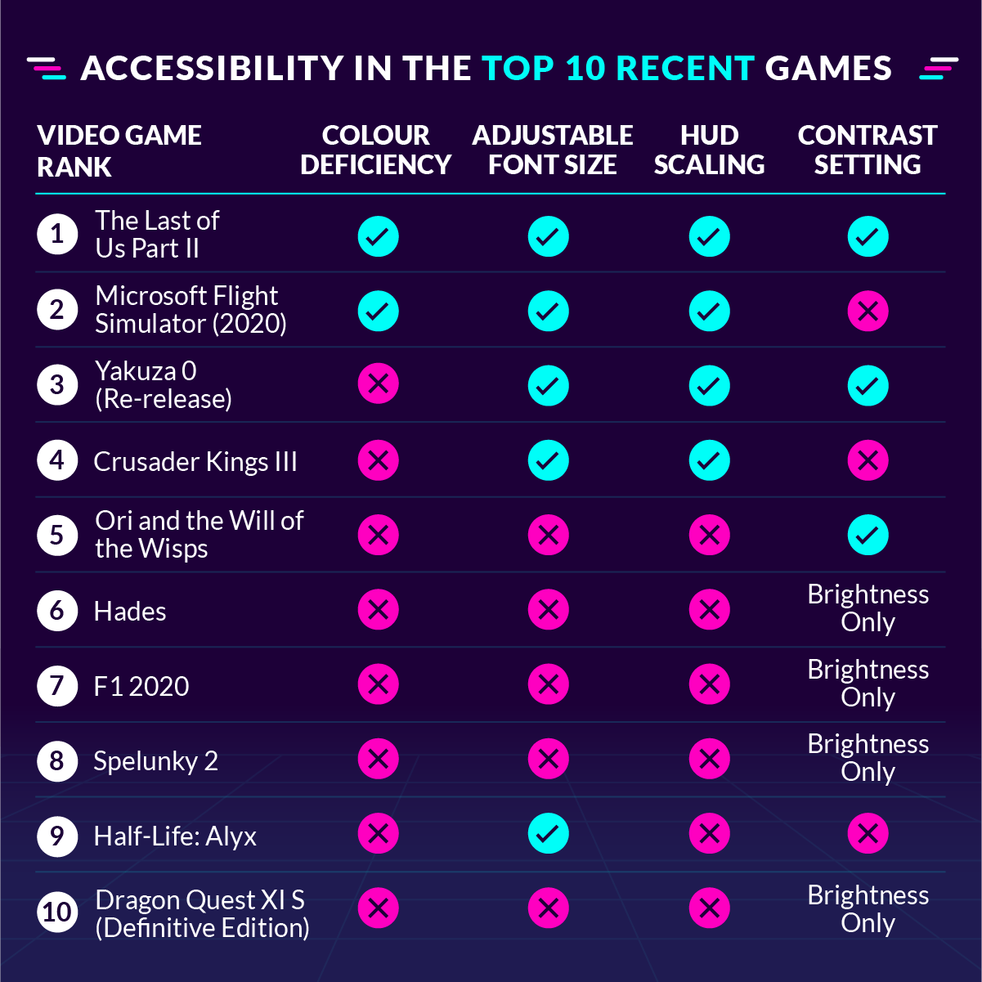

It’s immediately clear that games with support for colour deficiency aren’t as widespread as they could be. While games which also appeared in the most accessible games list, like The Last of Us Part II and Microsoft Flight Simulator, offer distinct modes to support vision-impaired users, other popular games like F1 2020: Spelunky offer no setting options at all, and instead rely on what can be changed on the console.

Interestingly, Half-Life: Alyx, which is a virtual reality game requiring the use of a headset, possesses some limited accessibility features including some not listed here, like playing with only one controller or reducing the intensity of lighting effects, which would benefit those with motor impairments and who experience negative reactions to flashing lights.

Although it didn’t make it into the top-rated games (the PC version scored the highest on Metacritic at 85/100), Cyberpunk 2077 was the biggest digital game launch of all time. Recurring bugs and underdeveloped systems drove the score down, but how accessible is it? Players can expect multiple aim assist options, including an enhanced “snap to target” function, as well as the option to remove weapon sway. Text size can be adjusted, and filters for protanopia, deuteranopia and tritanopia are all available.

Top 10 video game characters with disabilities [7]

10. Huey Emmerich – Metal Gear series: born a paraplegic and used a wheelchair due to his abnormally-shaped spine. Modified wheelchair so it could climb stairs. Eventually, made an exoskeleton that allowed him to walk upright without the need for his chair.

9. Xiahou Dun – Dynasty Warrior series: lost an eye in battle, caused a lot of anger and madness for the character but was also a driving force and motivated him in overcoming his obstacles. Still fought as a warrior and was a force to be reckoned with.

8. Kenshi – Mortal Kombat series: Permanently blind – learned to use other senses to compensate for loss of sight and was able to unlock the full potential of his mind. Became a master of telekinesis, deflects projectiles, and can teleport by bending space with his mind. Losing his eyesight only served to make kenshi a more capable fighter.

7. Lester Crest – Grand Theft Auto: suffers from an unspecified wasting disease which gradually wears down his motor skills as he ages. He is able to walk short distances with the use of a cane, but spends most of his time in a wheelchair. He also suffers from asthma and has struggled with weight issues since he’s unable to get proper exercise. But he is a genius and an eye for detail, a criminal mastermind.

6. Bentley – Sly Cooper Series: Has near-sightedness which caused him to lose his siblings and wander into an orphanage. Legs were injured during the final act of Sly 2. His paralysis made him more insecure, and he began to worry about burdening his friends. Ironically, he was more mobile in his wheelchair than when he was able to walk (as turtles aren’t know for their speed). In time, he regained his confidence and discovered there’s more than one way to stand up for yourself.

5. Joker – Mass Effect series: Born with Vrolik syndrome, which causes extreme brittleness in the bones. He finds walking impossible and relies heavily on crutches and leg braces to get around. He knew his medical condition would make him unlikely candidate to pilot a starship, so he hijacked the most advanced frigate in the fleet to prove himself, was court martialled for it but ultimately was named pilot of the vessel.

4. Taimi – Guild Wars 2: has a degenerative disease that prevents her from walking long distances. Despite this, she is fiercely independent and won’t allow anyone to take pity on her. Has help of a giant golem named Scruffy, she often sits in their hands or stands on its back, but she can also climb inside if she needs to be protected during a fight. Scruffty’s presence serves as a constant reminder of Taimi’s condition, but she’s defined by her personality rather than her disability. She’s known for her quick wit and strong work ethic, and she’s always supportive of her friends and guildmates.

3. Diogenes – Getting over it with Bennet Foddy: A muscular man whose lower body is confined within a black cauldron for some unknown reason. Although he’s unable to use his legs, he manages to scale mountains and various obstacles by relying entirely on his upper-body strength and an oversized Yosemite hammer.

2. Dunban – Xenoblade Chronicles: Sacrificed right arm in battle, he had no regrets over the ordeal, however, and he simply adjusted his style so he could fight with his left arm instead.

1. Baiken – Guilty gear series: When a child, Baiken’s left eye was gauged out and her right arm was severed in an attack that also claimed the lives of her parents. Her traumatic past transformed her into an aggressive, anti-social women who was fuelled by vengeance. She is physically disabled and has no supernatural powers, but her skills with a sword make her own of the deadliest fighters.

Diversity in gaming: Mental health & disabilities [8]

-Mental health has only been tackled in the last few years 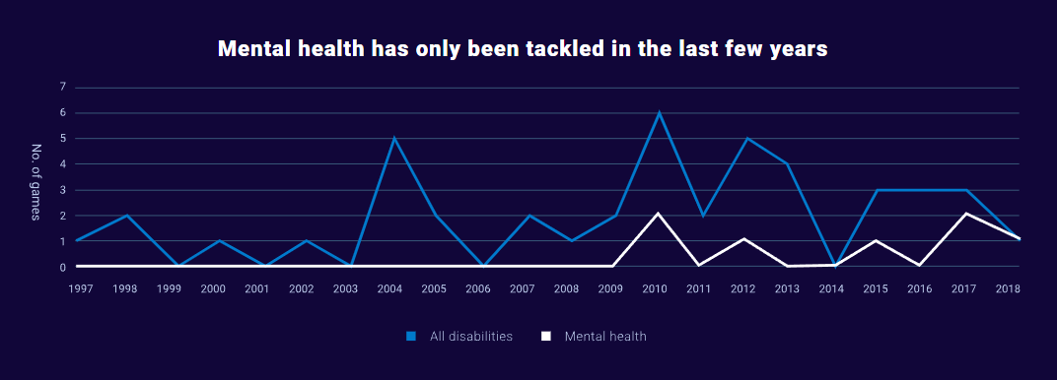

Physical disabilities are portrayed in games most often

* This might include amputees, burn victims, victims of ballistic trauma, wheelchair-bound characters and more. For developers, these are the disabilities they’re most likely to tackle. More nuanced issues, like anxiety and depression, are far less prevalent in games.
* Physical: 54%, Sensory: 20%, Mental: 20%, Physical/Mental: 3%, Sensory/Physical: 3%

Characters with a disability are most likely to get “fixed”

* “Fixed” is being used consciously to reinforce the reality that these are gaming constructs; “fixes” in real life are, of course, not as easy to come by and games are often guilty of throwing a catch-all fix into the mix. Accessibility expert Ian Hamilton agrees.

Ian Hamilton: “*This notion that people with disabilities are broken and need to be fixed – a concept known as the medical model of disability – was rejected and abandoned in the 1970s, yet still persists in media, and in games, often through the trope of medical conditions being replaced by superhuman powers or superhuman prosthetics. Moreover, games are often guilty of furthering the myth that a disability is rare, with all the impact that has on broader prejudice and discrimination.”*

Characters might have multiple conditions

* BJ Blazkowicz is not only wheelchair-bound for the early parts of Wolfenstein II: New Colossus, but the game also lifts the veil on his mental wounds, painting his PTSD in comic book strokes while revealing a character with a troubled childhood.

Disabled characters of note:

* Both the Joker and Lester Crest are wheelchair-bound, but the great thing about these characters is that their disability does not define them. The Joker, ace pilot of Mass Effect’s SS Normandy, suffers from Vrolik syndrome (brittleness of the bones), while Lester, the sardonic sidekick in Grand Theft Auto V, has an unnamed wasting disease. Yet both men are fiercely independent despite the challenges they face.

Ian Hamilton: “*Representation of characters with disabilities is still rare. It is often simply not on people's radars. And when it is, fear of handling it badly can put people off. When it comes to accessibility [creating games that disabled players can enjoy], the situation has changed profoundly. It’s now a mainstream topic."*

Disabled characters are few and far between in games. Characters with mental illnesses are rarer still. Enter Hidetaka Suehiro’s Deadly Premonition, which follows FBI profiler Francis York Morgan. Strangely, Morgan spends his time talking to an imaginary character, Zach. Yet what starts off as a curious subplot turns into a fascinating exploration of mental health.

The need for more disabilities in the games we play [9]

Video games have grown popular in today’s culture. Because of this, their growing popularity could be used to educate, if the companies offer an accurate representation of the disability, whether it be physical or mental.

Ideas to expand on disabilities in video games:

Physical Disabilities: A game based on wheelchair basketball. Like any other sports game except with wheelchair basketball. Another option is to add disabled people in a wheelchair for basketball video games. They do have a wheelchair simulator game, which feels like a game that makes using a wheelchair the punchline of a joke. They would like to see the game developers have some serious interpretations of disabilities.

Mental Disabilities: there are examples of mental disabilities in video games. Autism gets represented in Watch Dogs 2 in a character called Josh. He is a genius but has trouble understanding social cues. He won’t process emotion like others and he does not understand slang. This is one representation of someone with Autism, or at least on the spectrum. Hellblade: Senua’s Sacrifice’s main character, Senua, has Psychosis. Symmetra in Overwatch is another leading character with Autism. Rogue Legacy is another game that has a “colourblind” perk that the player character could inherit a trait where they only see the world in black and white.

What part can companies play: If physical disabilities get added in games, this could bring awareness to more disabilities. More people would be made aware of disabilities, especially if the representation was accurate, such as Symmetra from Overwatch who has Autism. This could even show unseen physical or mental disabilities as well, like a spinal injury you don’t see.  Hellblade focused on a character with Psychosis and won numerous awards. The creators of Hellblade also worked alongside knowledgeable people to represent actual factual representation.  It would be nice to see player characters and non-player characters with disabilities in the games because it could also be therapeutic helping those with disabilities, playing a game with disabilities added while helping to educate those who don’t have disabilities.

*Colourblind accessibility in video games*

[10]Some video games have taken colourblind accessibility into account, but including these features is one matter, but ensuring these games are truly accessible too colourblind gamers is another.

Types of colour-blindness:

* **Protanopia –** unable to perceive red light, resulting in red and greens looking murky, and blue and yellows standing out
* **Deuteranopia –** unable to perceive green light, resulting in red and greens looking murky, and blues and yellows stand out
* **Tritanopia –** unable to perceive blue light, resulting in greens looking murky, and reds appear pink

Approaches to colourblind accessibility in games

Filters: The most common way of implementing colourblind accessibility in games is including modes for the different types of colour-blindness via a whole-screen filter. This is meant to target the problem colours for colourblind people; however, these filters tend to oversaturate the entire colour palette, resulting in some undesirable colours.

Customizable colours for vital information: Another way to implement colourblind accessibility in video games is to include preset or customisable colour combinations, based on types of colour-blindness, for representing different types of vital information in the game. This method tends to receive more favourable feedback from those with colour-blindness since it only induces changes in colours that are problematic, without altering the rest of the game’s colour palette.

Incorporating iconography as supplementary conveyance: Perhaps the best approach to colourblind accessibility is including iconography as a form of supplementary conveyance. While it is best practise to convey (vital) information via multiple methods (e.g. the “trifecta” – audio, visual, and textual conveyance), it is not always plausible. It is imperative that vital game information not be conveyed solely by colour, as it could negatively impact the experience of a player who struggles to see the specific colour.

In conclusion,

1. Whole screen filters are, typically, not the best approach to colourblind accessibility
   1. Colourblind people see a limited range of colours.
      1. Compressing the entire colour palette pushes hue away from the problematic areas and bunches them up closely against other hues, swapping colour clashes for other colour clashes.
   2. Changing all the colours that are distinguishable to those with colour-blindness makes the game look bizarre and unnatural.
      1. Do not alter that which does not need to be altered.
      2. Help the player distinguish between vital information necessary to play the game.
      3. A player should not experience colours in games differently than they perceive them naturally in the world
2. Ideally, provide the option to let players select and customise colours for vital information
   1. These can be applied to outlines, health bars, icons, names, object indicators, etc.
   2. “One size does not fit all”
      1. There are varying degrees of colour-blindness, so customisation can offer a personal and, ultimately, more optimal experience.
3. Avoid relying on colour alone (by adding symbols, text, varying enemy design, etc).
   1. If not possible, include a simple colour palette that can be used as a single-colour choice that is not problematic for those with colour-blindness (e.g., dark orange/light blue)
   2. If neither of these are possible, a brief review of the game aspects that absolutely need to be differentiated to play the game successfully (e.g., teammates vs enemies) can be done to decide if specific UI/gameplay elements can be modified.

For some developers, colourblind accessibility is incorporated into the development of a game from the beginning whereas, for others, it may be an afterthought or complete oversight, accidental or not. The latter is understandable for many reasons: a lack of budgeting allocated to such resources, timing crunch, lack of flexible toolkit for designers, etc. If usability research is incorporated into the development schedule from the beginning, feedback on colourblind features (or lack thereof) can be noticed/iterated/implemented/tested before it is too late to include such accessibility.

The important question is, how will future games approach colourblind options in games? Will developers revisit previously unsuccessful methods, as Madden 17 seems poised to do, learn which games have been successfully lauded by colourblind players, like Battlefield 4, or be proactive in implementing innovative systems that allow full accessibility for colourblind players, à la Recore?

Use shaders for colour-blind settings[11] - won’t have to touch your textures or otherwise hardcode colours in. All it takes is a fragment shader that modifies certain ranges of colour to a range more suitable for the colourblind. Best of all, these can be completely customisable for different types of colour-blindness.

Avoid red and green combinations – 5% of the male human population have red-green colour-blindness (said someone on reddit)

Battlefield 4 colour-blind settings - <https://imgur.com/gallery/iBRGY#kOmonaA>

Simulate colour-blindness - <https://paletton.com/#uid=1000u0kllllaFw0g0qFqFg0w0aF>

1. Rouner, J. (2017). *Video Games Need More Playable Disabled Heroes*. [online] Houston Press. Available at: http://www.houstonpress.com/arts/video-games-need-more-playable-disabled-heroes-8321466 [Accessed 1 Mar. 2017].
2. Ready Players. (2016). *Little Metal Limbs – Portrayals of the Disabled in Games*. [online] Available at: https://readyplayers.wordpress.com/2016/06/23/little-metal-limbs-portrayals-of-the-disabled-in-games/ [Accessed 7 Jan. 2019].
3. Cullen, A.L., Ringland, K.E. and Wolf, C.T., A Better World: Examples of Disability in Overwatch.
4. https://www.xbox.com/en-GB/community/for-everyone/accessibility
5. https://www.lenstore.co.uk/research/videogame-accessibility/
6. <https://www.inverse.com/gaming/best-accessible-games-gaad-2021>
7. <https://www.blockfort.com/character-lists/physicallyimpaired/>
8. <https://techtalk.currys.co.uk/tv-gaming/gaming/diversity-in-gaming/games-and-disabilities.html>
9. <https://ablegamers.org/the-need-for-more-disabilities-in-the-games-we-play/>
10. <https://www.gamersexperience.com/colorblind-accessibility-in-video-games-is-the-industry-heading-in-the-right-direction/>
11. <https://www.reddit.com/r/gamedev/comments/1nkduo/adding_colourblind_modes_to_a_game/>